**DAILY ONLINE ACTIVITIES SUMMARY**

|  |  |  |  |  |  |  |  |  |
| --- | --- | --- | --- | --- | --- | --- | --- | --- |
| **Date:** | **12-06-2020** | | | | | **Name:** | **Sinchana** | |
| **Sem & Sec** | **6 B** | | | | | **USN:** | **4AL17CS117** | |
| **Online Test Summary** | | | | | | | | |
| **Subject** | |  | | | | | | |
| **Max. Marks** | |  | | **Score** | | |  | |
| **Certification Course Summary** | | | | | | | | |
| **Course** | **Python programming** | | | | | | | |
| **Certificate Provider** | | | **E-box** | | **Duration** | | | **2 hours** |
| **Coding Challenges** | | | | | | | | |
| **Problem Statement: 1.magic square width 2.binary tree** | | | | | | | | |
| **Status: Success** | | | | | | | | |
| **Uploaded the report in Github** | | | | | **Yes** | | | |
| **If yes Repository name** | | | | | **coding** | | | |
| **Uploaded the report in slack** | | | | | **Yes** | | | |

Online Test Details: (Attach the snapshot and briefly write the report for the same)

Certification Course Details: (Attach the snapshot and briefly write the report for the same)

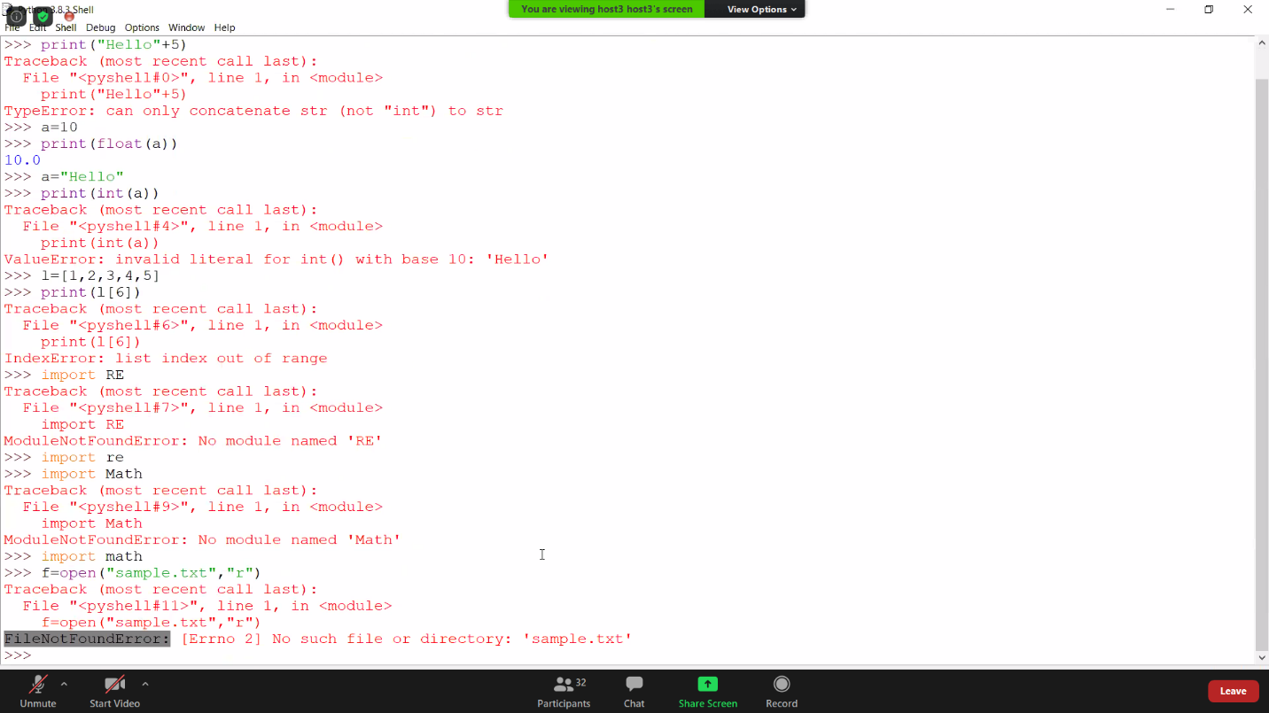

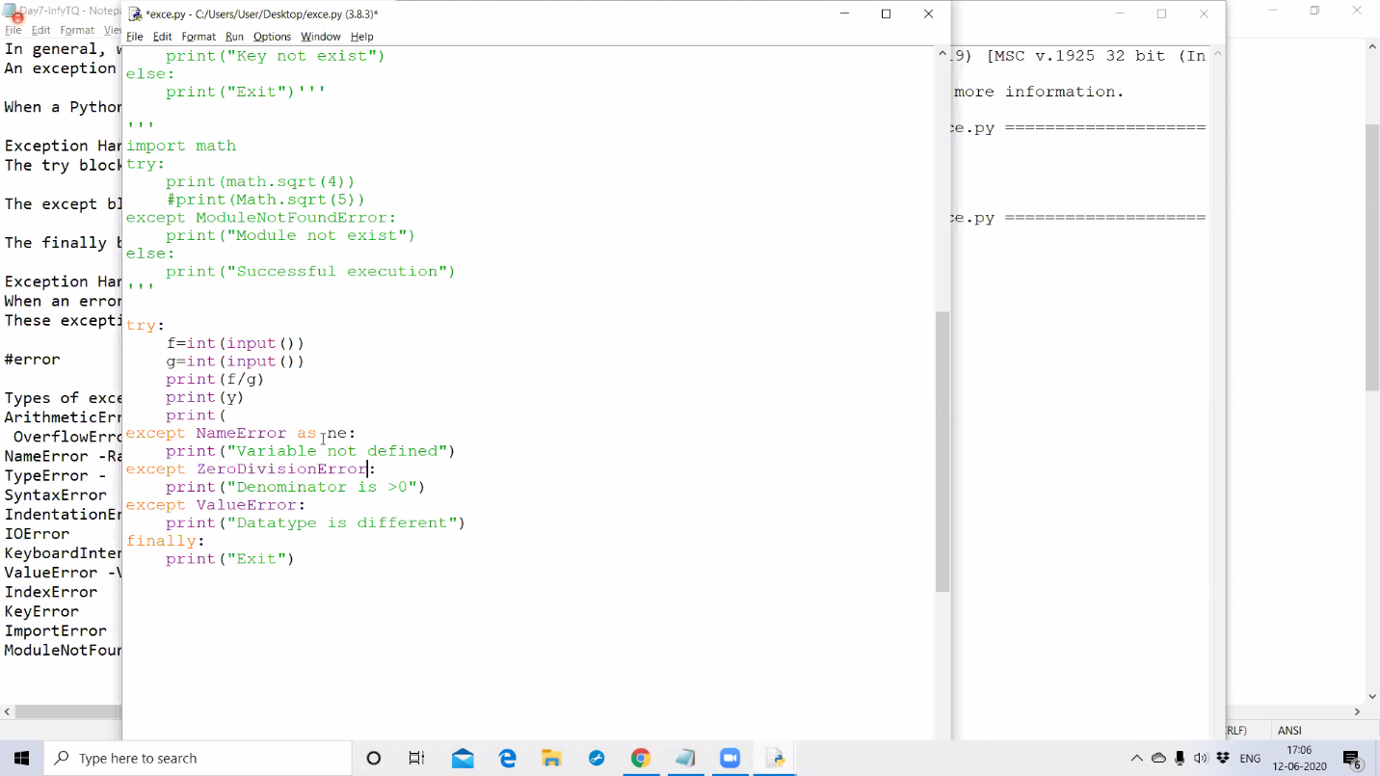

Today I have learnt about an exception handling which has the features to handle the unexpected error occurrence. Even learnt about different types of error such as type, syntax, indentation error and how it occurs.

Coding Challenges Details: (Attach the snapshot and briefly write the report for the same)

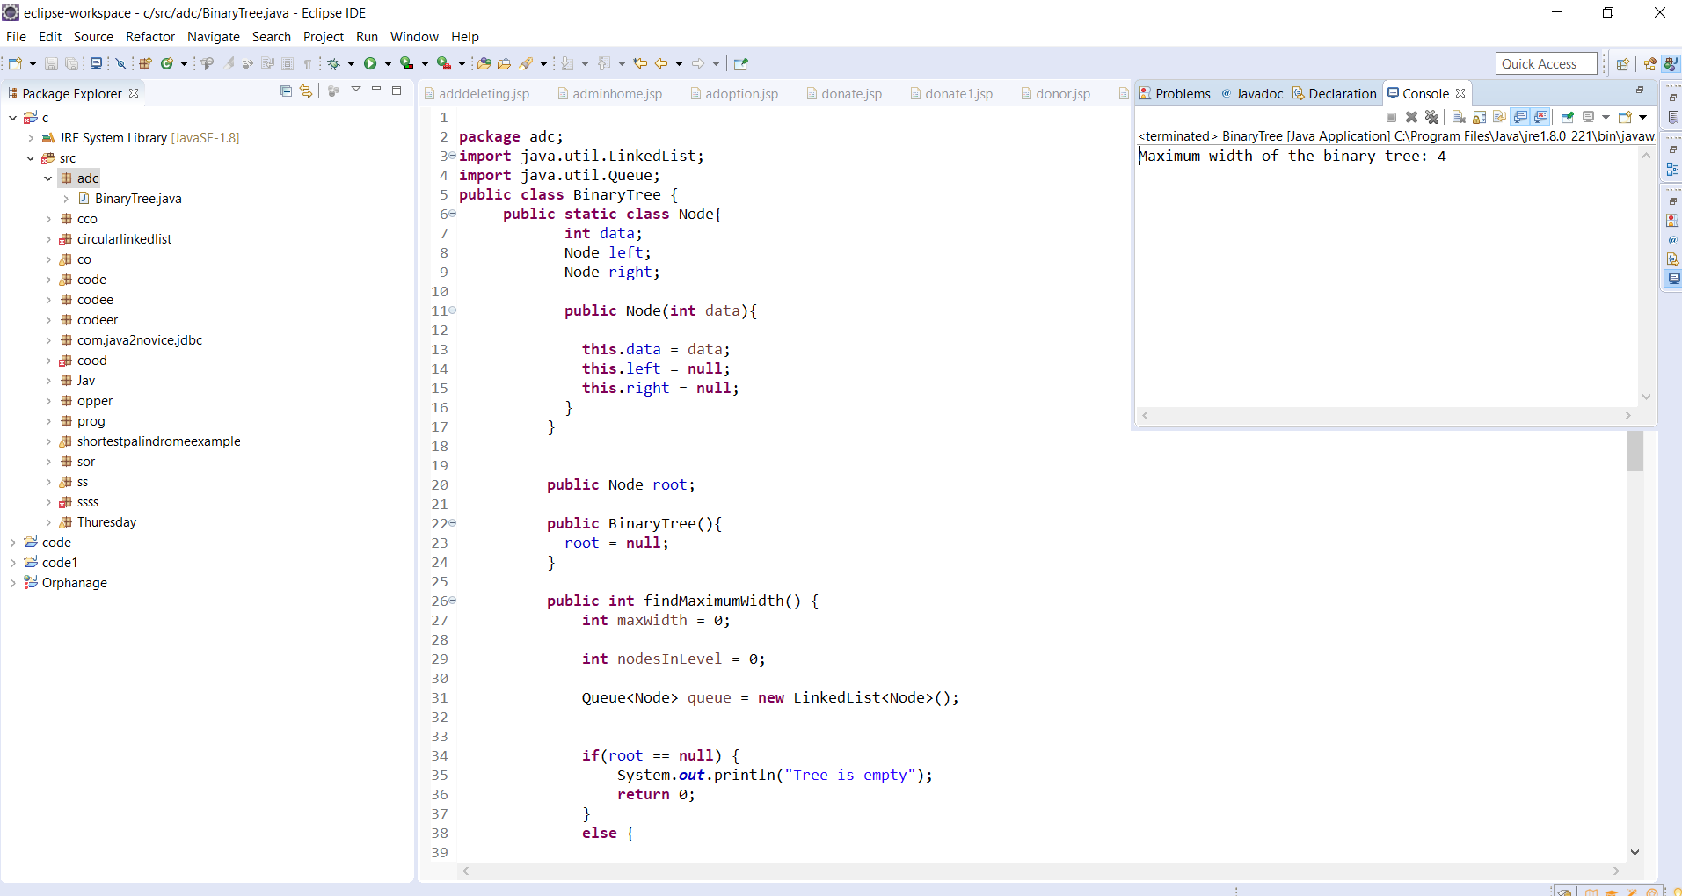

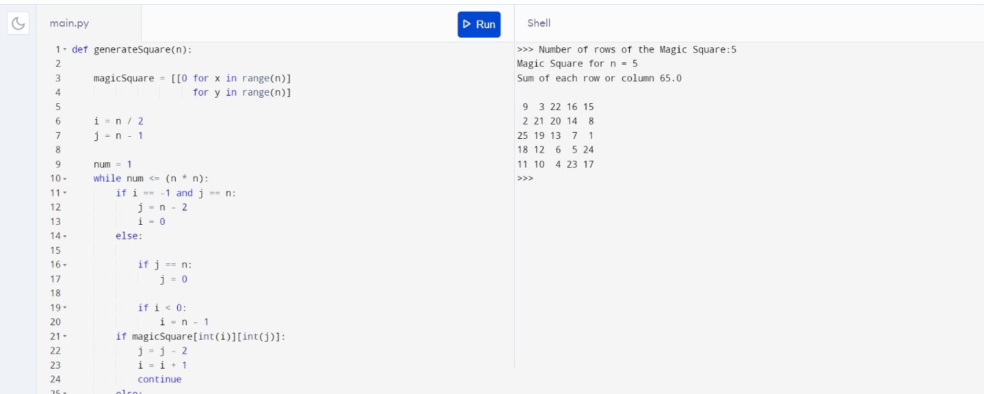

Link in GitHub : <https://github.com/sinchana514/coding>

<https://github.com/sinchana514/coding/tree/master/12th%20june>